**https://www.youtube.com/watch?v=VnqrMwpZM7E**

**Gulp**

Step1:

Install Node.JS

1. Check the node **installed or not** [ cmd : node -v ]
2. Check the NPM [Node Package Manager] [ cmd: npm -v]

Step2:

Create Package.json in the respective folder

Step2:

Gulp installation cmd

Step1:-

* 1. **Cmd : npm install gulp**
  2. **Cmd : npm install gulp -g or npm install -g gulp**

info:-

* + Npm -stands for Node package manager
  + g – stands for Global

Step3:

check the Version of the Gulp

* **gulp -v** (Check the version)
* **npm install –save-dev gulp gulp-util or npm install gulp gulp-util –save-dev**

Step4:

After installation, some dependencies are added in the package.json

Step5:

Need to add some configuration in the gulpfile.js

New we are install only **gulp and gulp util**

var gulp = require('gulp');

var gulputil = require('gulp-util');

gulp.task('default', function () { })

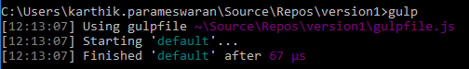

Step5:

Now we are going to install concat

* install concatenation library [Cmd: **npm install –save-dev gulp-concat**]
* whatever we install that should be added in the package.json

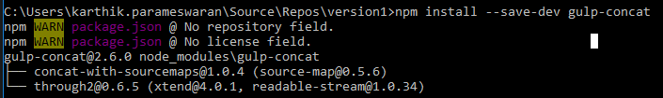

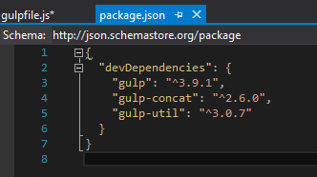

Step5:

Then we need to configure gulpfile.js

* + 1. config the scripts files, source and destination